**Monday May 13th, 2019 Daily Coding Journal**

NOTE: The following journal is working through exercises from this course: <https://scrimba.com/playlist/p7P5Hd>and today is focused mostly if not entirely on the following video: <https://scrimba.com/p/p7P5Hd/cgDqBHP>

9:58 — A pomodoro session a day keeps the poor man’s house away… or something like that. Anyway, here we are again ready to do some more learning!

10:07 — I’ve been trying to rebuild the solution from scratch. Adding a console log in my handleChange function is easy enough. Adding a prop of *handleChange={this.handleChange}* is also easy enough.

10:08 — The thing I don’t get however, is exactly how the following line of code should go:

onChange={() => this.handleChange(props.item.id)}

10:09 — I spent probably 30 minutes on just this line of code yesterday but I don’t seem to have fully retained what needs to be done here. I know that first we have our onChange event handler that’s listening for some event to occur. Then we have an empty event with a function that should return the values being returned from our handleChange method. I’m making some small error in syntax, however, that resulting in an error that handleChange is undefined, however.

10:14 — Apparently the working solution is:

onChange={() => props.handleChange(props.item.id)}

10:15 — I find this pretty bizarre though as I’m almost sure I went through the following logic at least once. Oh well, I’ll get it next time.

10:19 — Now I’m doing some work with .map( ) to see if I can change the state of my todo-items from true to false.

10:21 — If I console.log( ) the following:

console.log(this.state.todos)

I’m returned a huge list of data, which is exactly what I’m looking for.

10:25 — While console.logging the data I need is easy enough, I need to figure out how to use the map method without it returning a bunch of null values.

10:30 — I’m going to spend some time copying code by hand to help meditate on and gain a better understanding of both syntax, and *why* the code is doing what it is doing.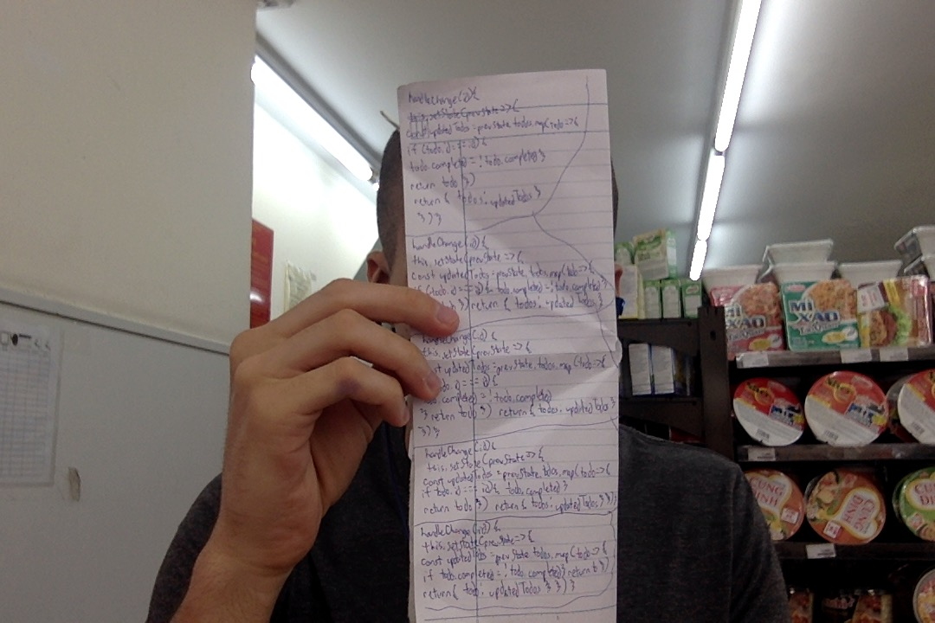

10:44 — While I kind of understand the above code, I’m not yet sure that I could replicate it on my own. I think I’ll need some more practice to do so. On the bright side, while this pomodoro session is over, I’m going to commit to coding for another hour or so today!

**Total time spent coding today: N/A**

**Total time spent coding thus far in May 2019: N/A**

**Total lifetime hours of coding: N/A**